­­­­FOR THE LOVE OF THE LAND

Such lovely – but odd – weather we have been having! We seem to have skipped winter and gone straight to spring! The natural cycles are all cattywampus; some plants flowering earlier than usual due to increased heat, others later than usual because of low rainfall. And ohhh, the rainfall. According to [weatherdb.com](http://average-rainfall.weatherdb.com/l/21049/Portola-Valley-California), average rainfall for Portola Valley for January and February is 16.51 inches. For that same period in 2014, only 2.96 inches were recorded. The drought is predicted to remain in full swing in the West, as you can see in the NOAA graphic below.

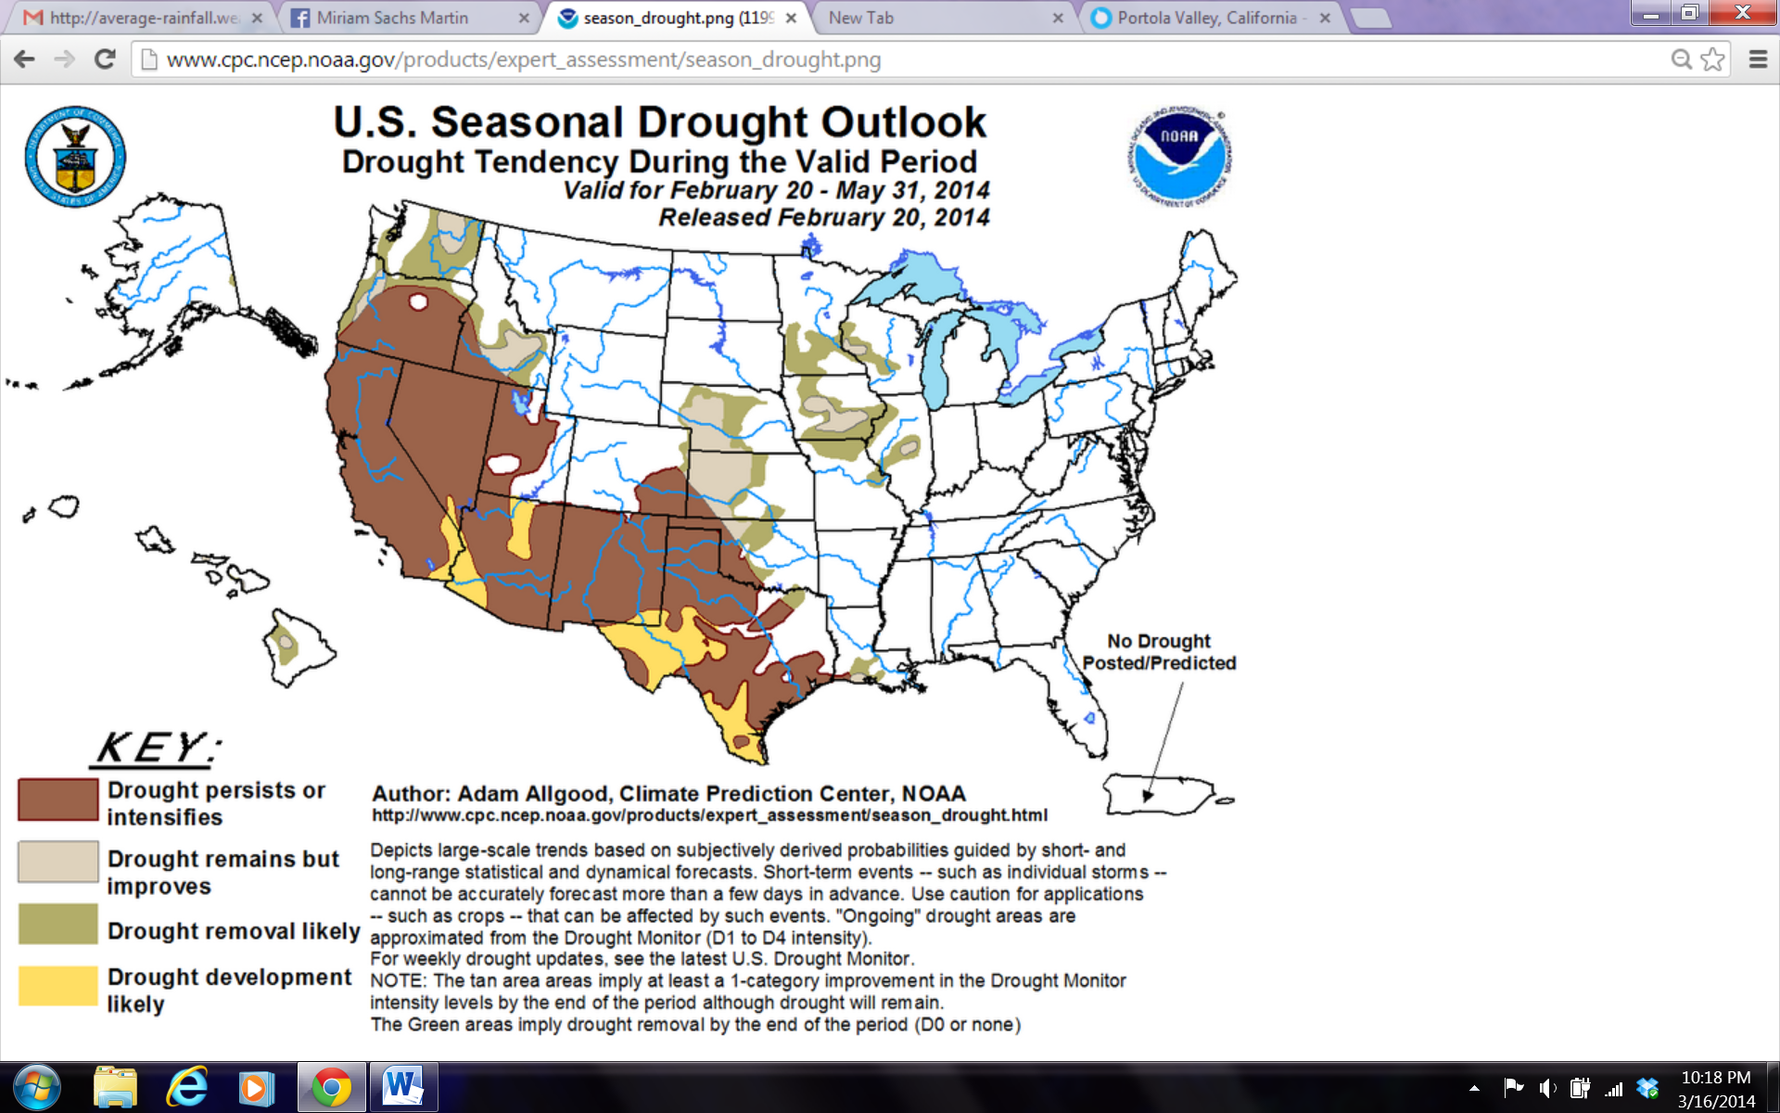What that might mean practically for PVR residents: the upcoming fire season may be fierce, so prioritize your vegetative fuels reduction now. Also check your irrigation. Many mature native trees and shrubs - particularly manzanita and Ceanothus – not only don’t need supplemental water, but it actually can shorten their life span. If you inherited your drip system when you bought your house, it may be time to consider what plants can be taken off it now. Lastly, as the drought continues, new plants will appear more tender and succulent to herbivores. Deer and gopher cages may be in order!

Land management of Association property will include a similar focus on preventative fuel reduction, a plant order half the size of last year’s, and more emphasis on weed control to take advantage of the low seedling rates. We will be monitoring grassland areas regularly and adjusting the mowing schedule accordingly. The double-mow meadow demonstration areas (Alpine and Bayberry) may be only mowed one time if that’s all the grass growth warrants.

**How Much Mulch?**

Now is a good time to practice mulch management for both plant health and fire safety! Look at the ground on your property. What’s on it? Is it bare dirt, easy to get compacted and exacerbate drought stress on plants? Is it several inches of leaf duff, ready to become a fire hazard come summer? Or is it a Goldilocks’ happy medium of 2-3 inches mulch, duff, or other organic matter?

Most homes will have some combination between the three scenarios in different parts of the yard. In that case, you or your gardener can practice good mulch management. Rake or shovel deep duff around to cover any bare areas. Strive for complete coverage but not enough to create a fire risk. If you run out of material, feel free to take up to a cubic yard (one pickup truck load) from the PVR mulch near the winery. Mulch, like all organic material, breaks down and changes over time. So it’s worthwhile to take a look once or twice a year.

**Oak Worm Monitoring**

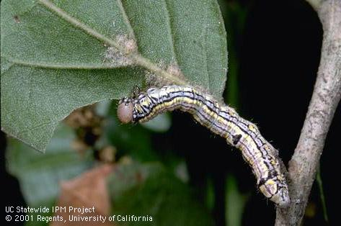Oak worms (*Phryganidia californica*) are a natural and normal part of the woodland environment. However, we’ve had a couple banner years of them and some homeowners have expressed concern about the phenomenon. If you felt negatively affected by oak worms in the last year or two, you may want to monitor caterpillar activity now. Go to the west side of several live (evergreen) oaks and several valley (deciduous) oaks. Position yourself under a branch that’s low enough to see the leaves, and look for caterpillars. Here’s a close-up picture, but at this time of year, any little green or yellow-tan caterpillars curled up under oak leaves are likely to be oak worms. More than 8-10 caterpillars per 25 leaves, and you may have a heavy infestation. Contact your arborist for more information on oak worm management and less-toxic control options. The UC IPM has an excellent article: <http://www.ipm.ucdavis.edu/PMG/PESTNOTES/pn7422.html> which can tell you much more than you probably ever wanted to know about this little native critter. C:\Users\PVR Office - Miriam\AppData\Local\Microsoft\Windows\Temporary Internet Files\Content.IE5\RR9RZGXX\MC900434575[1].wmf

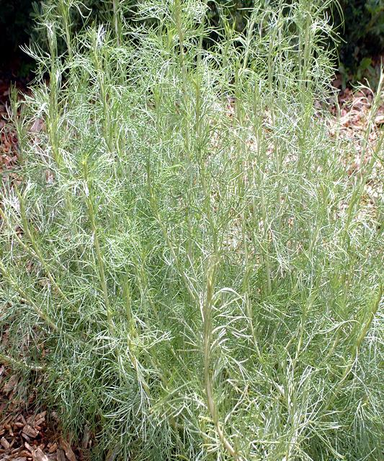**Species Spotlights:**  A few folks have asked about the fun feathery foliage of California Sagebrush – *Artemisia californica*. This plant stands out now – before the primary blooms of the season have burst. Although its own flowers are insignificant, its airy form and silver-green color add a playful and flower-like quality to the landscape. It can be heavily pruned or allowed to wander. It’s locally native, deer resistant (practically deer proof!), needs little water, takes full sun, and has a marvelous scent.

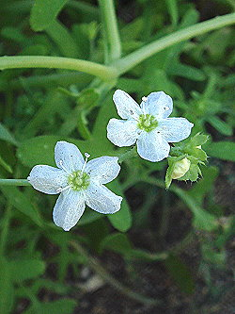There are some other neat natives in the front landscaping that we didn’t plant, but that had viable seeds lying dormant in the soil all these years. These are miner’s lettuce *(Claytonia perfoliata)* which is all the rage these days with “foraging foodies.” I was recently told it sells for $10 a pound! White Fiesta Flower (*Pholistoma membranaceum)* is another cool self-starter.

*White Fiesta Flower. Image from Calflora.net.*

**Landscape Calendar**

\***It’s nesting and mating season, so please be careful and survey for critters before doing your work. Many nesting parents are easily startled.\***

*Now is a good time to prune Toyon, Pacific Wax Myrtle, and Coffeeberry. If they are tall and rangy, you can bring them down, if they drag on the ground, limb them up. These shrubs can often be the connector material which makes ladder fuels, so keep them off the ground and out of the oaks – space is the enemy of wildfire.

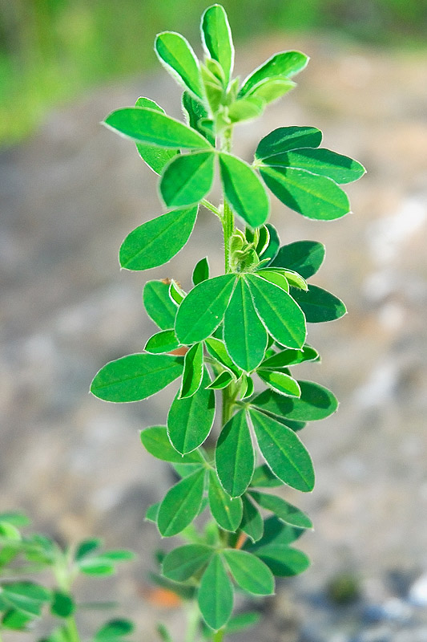*Weed season is in full swing! Dig out thistles and dandelions. Pull French Broom if you have one or two plants. If you spot a larger infestation that leads to association land, please notify me. French Broom is a top priority of the Landscape Committee.

*French Broom*

*California Sagebrush. Image from Larner’s Seeds.*

*Practice good mulch management.

*Keep irrigating any vulnerable, small, or new plants any time there has not been rain for a few weeks. Consider taking larger established plants **off** irrigation.

*If you have not already done so, fill out the 2013 Homeowners Fuel Reduction Form at: [www.surveymonkey.com/s/PVR2013FRMC](http://www.surveymonkey.com/s/PVR2013FRMC)

*Free consultations! Did you know that I’m available to visit any homeowner to discuss landscaping, pest management, fire safety, guideline compliance, and more? Email me to set up an appointment, I’m happy to help you prioritize best practices in your landscape!

**Thanks for reading!**

Got a question, concern, or kudo? I always enjoy hearing from you! Email is the best way to reach me, at landmgr@pvranch.org. I’m usually here on Mondays and Thursdays from about 10-6, but often come in at other times as well.

*- Miriam Sachs Martín, PVR Land Manager*